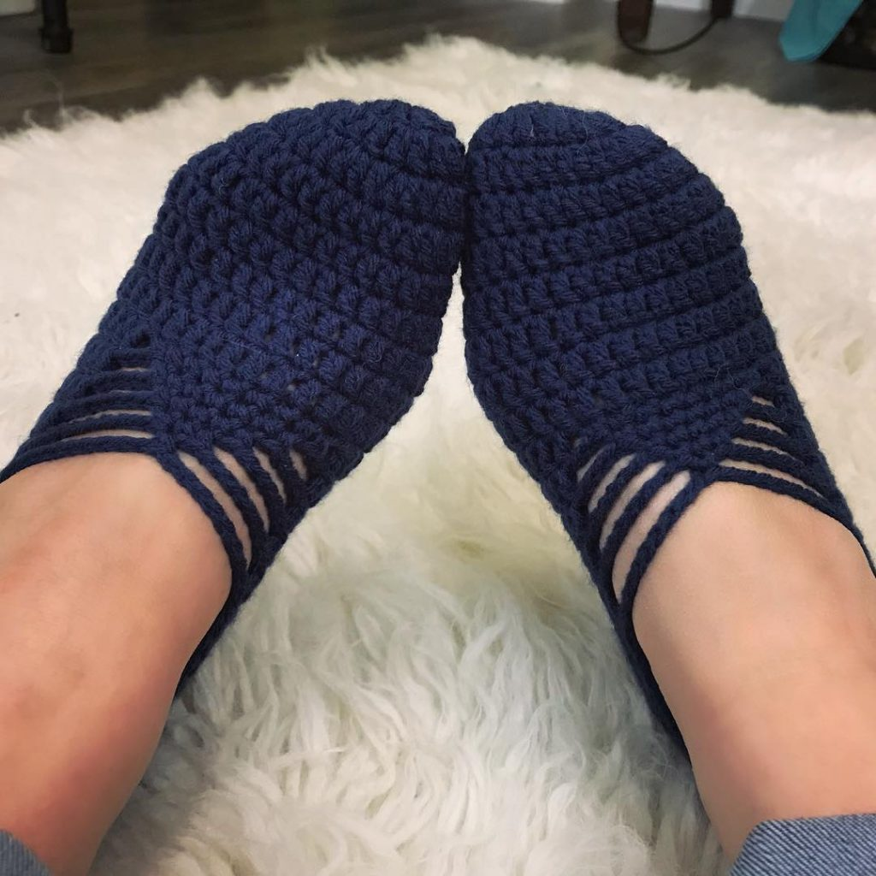
For this pattern we use around 100 – 120 yards of worsted weight/size 4/Aran yarn and a D/3.25mm hook. These ballet slippers work up quickly so grab your hook and let’s get started!

BALLET SLIPPERS CROCHET PATTERN
Materials:
Worsted weight/size 4/Aran yarn
-approx. 100 – 120 yards for women’s US size 7 – 10 (Big Twist “Dark Denim” pictured)
Crochet hook in size D/3.25mm
Sock Stop. Thanks, Gemma!
Pattern Notes:
Place first stitch of each row in the same stitch as your chain.
Ch-2 at beginning of round does NOT count as a stitch.
Pattern written in US terms.
Here’s a tutorial for the Magic circle. You could also Chain-4, join to first chain to form a circle.
Pin this pattern for later here.
Get the CHUNKY yarn and child size of this pattern here.
Get the ad-free printable version here. Thank you!
See the VIDEO tutorial below!
Pattern:
Round 1: Magic circle, ch-2, 10dc in circle. Join. (10)
Round 2: Ch-2, 2dc in each st around. Join. (20)
Round 3: Ch-2, * dc in first st, 2dc in next * repeat between * * around, join. (30)
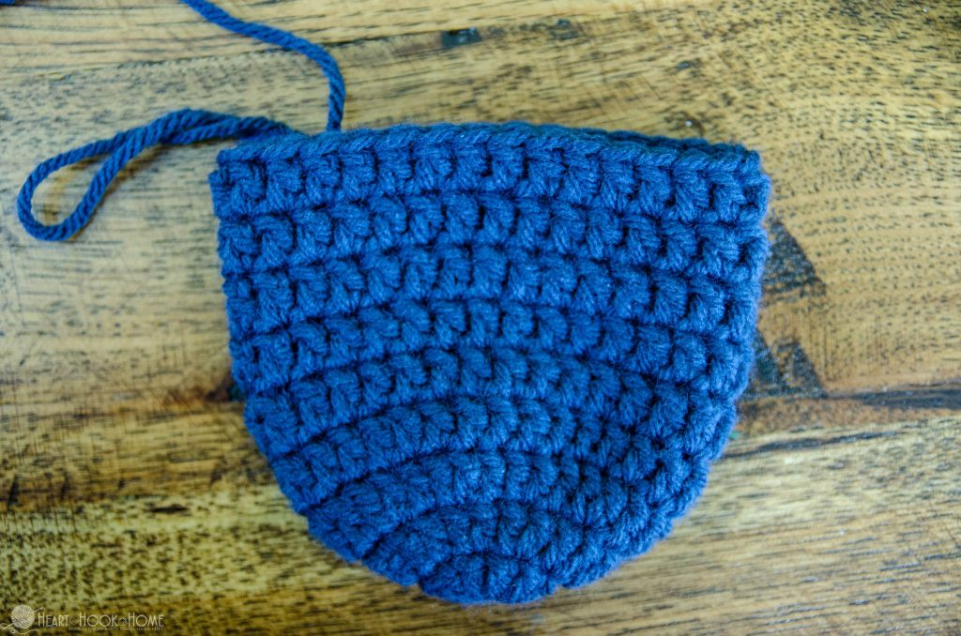
Rounds 4 – 9: Ch-2, dc in each st around. Join. (30)
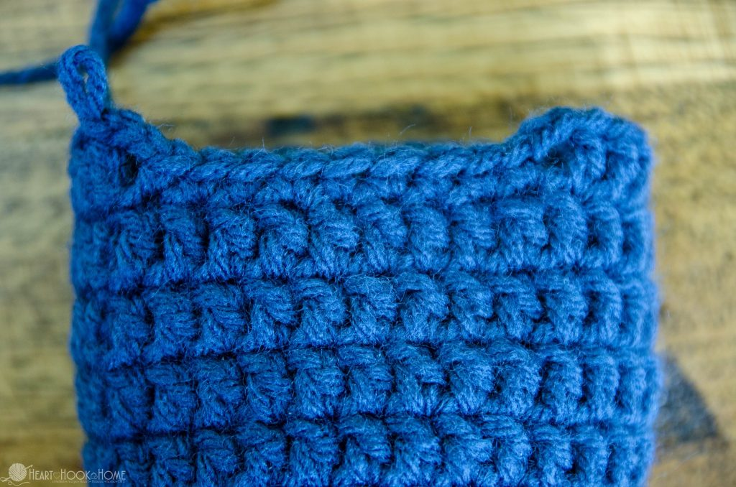
Round 10: Ch-2, dc in 21 sts. ch-2, sc in next 9 sts. Ch-2, sl to top of first dc.
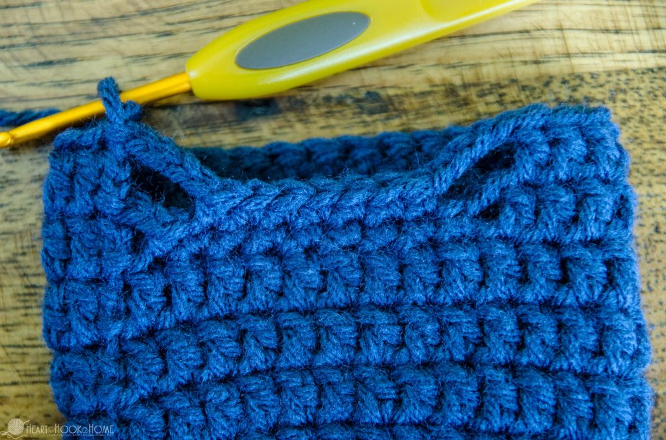
Round 11: Ch-2, dc in 21 sts, ch-4, sc in center 7 sts. Ch-4, sl st to top of first dc.
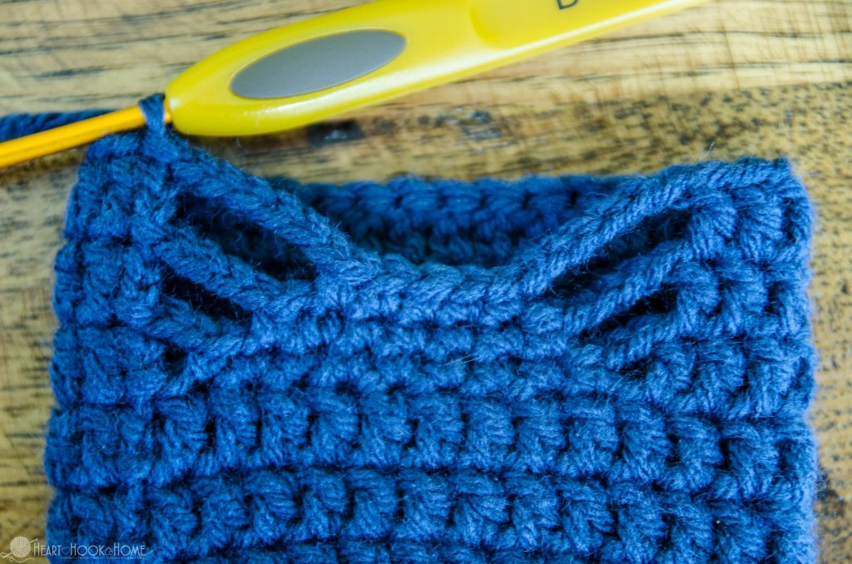
Round 12: Ch-2, dc in 21 sts, ch-6, sc in center 5 sts. Ch-6, sl st to top of first dc.
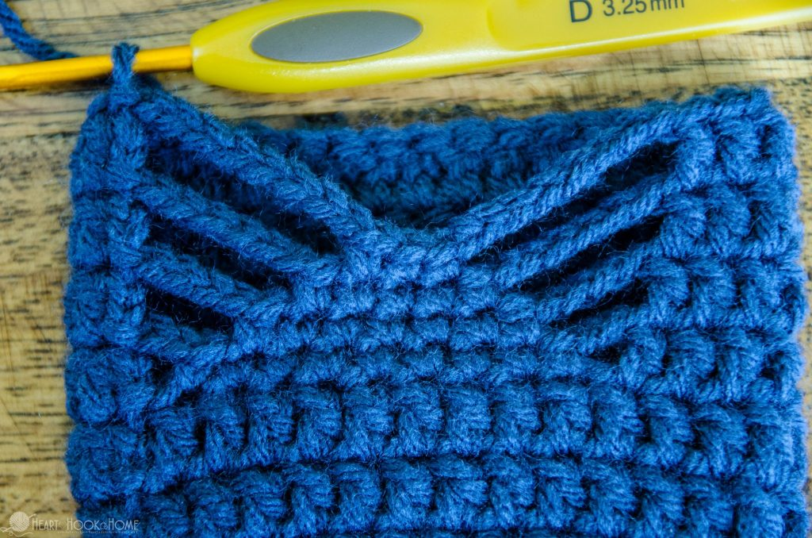
Round 13: Ch-2, dc in 21 sts, ch-8, sc in center 3 sts. Ch-8, sl st to top of first dc.
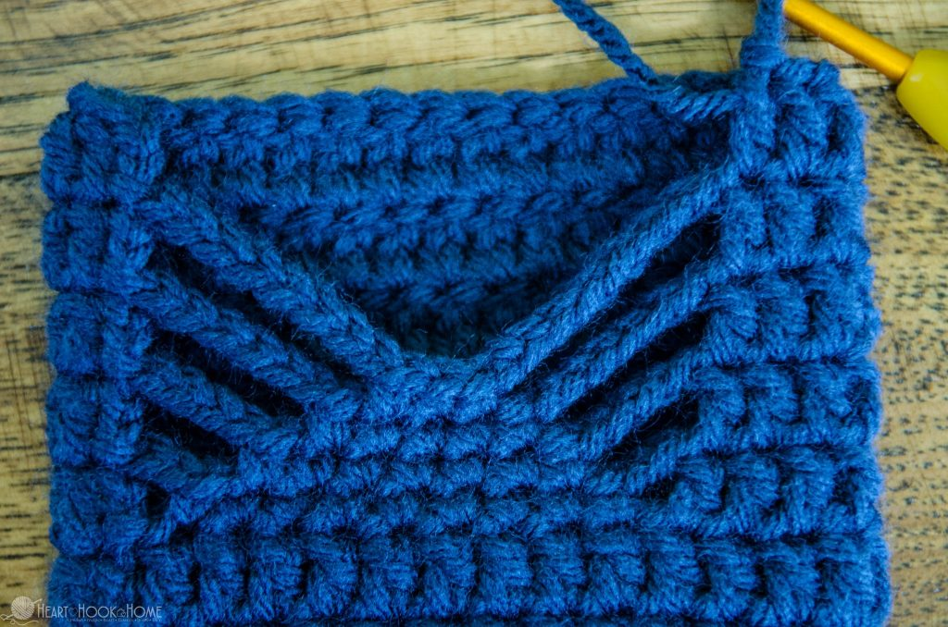
Row 14: Ch-2, dc in 21 sts. (21)
Row 15: Ch-2, turn, 2dc in first, dc in next 19 sts, 2dc in last st (23)
Row 16: ch-2, turn, dc in 23 sts (23)
Row 17: ch-2, turn, 2dc in first, dc in next 21 sts, 2dc in last (25)
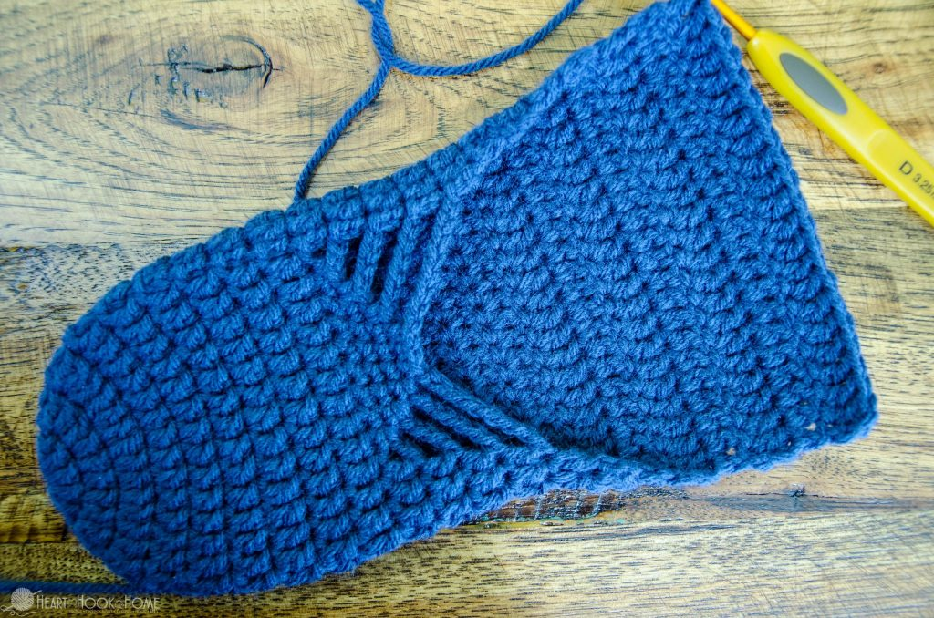
Rows 18 – length needed: Ch-2, turn, dc in 25 sts (25)
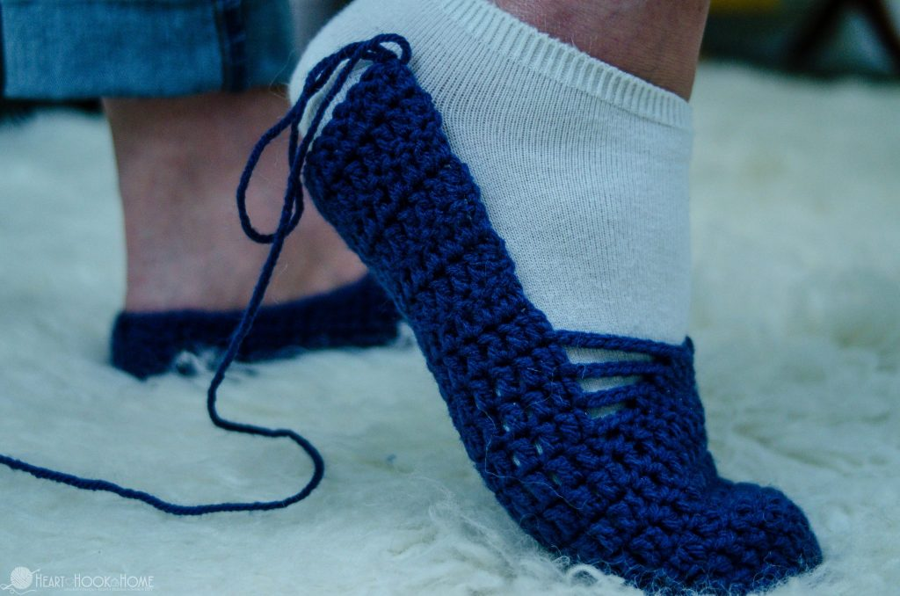
***stop when slipper length is 1” shorter than foot length***
Round 19 (or last row needed for size): Ch-2, turn, dc in 11 sts, dc3tog (middle of heel), dc in 11 sts. Do not fasten off, sl st to top of first st from this row to create the heel. Ch-1, turn if needed.
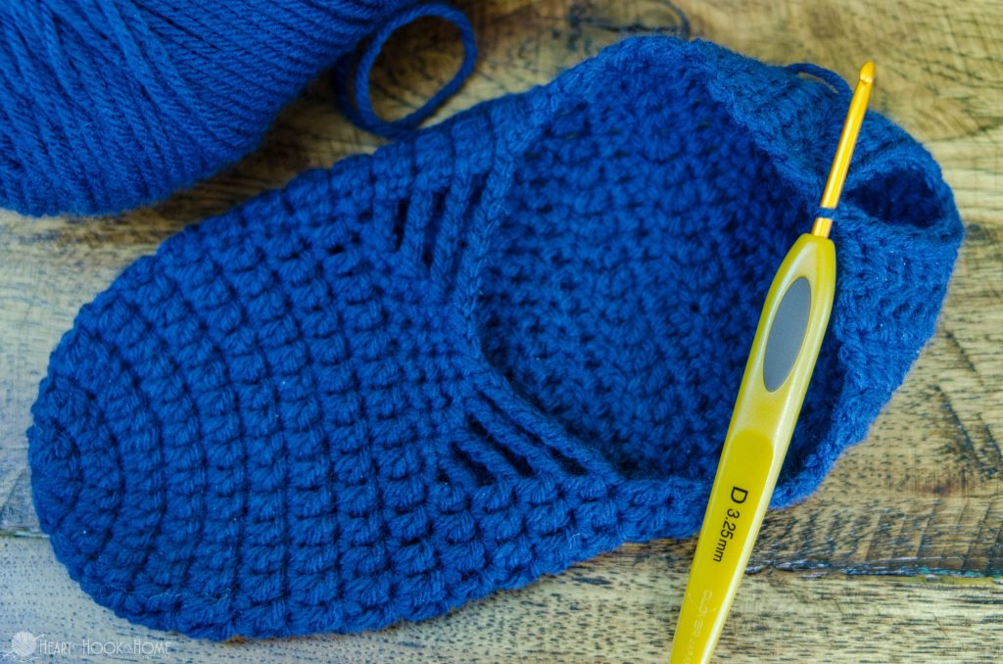
Around top of slipper, with slipper toe facing away from you: sc in each row end until you reach the top of row 14.
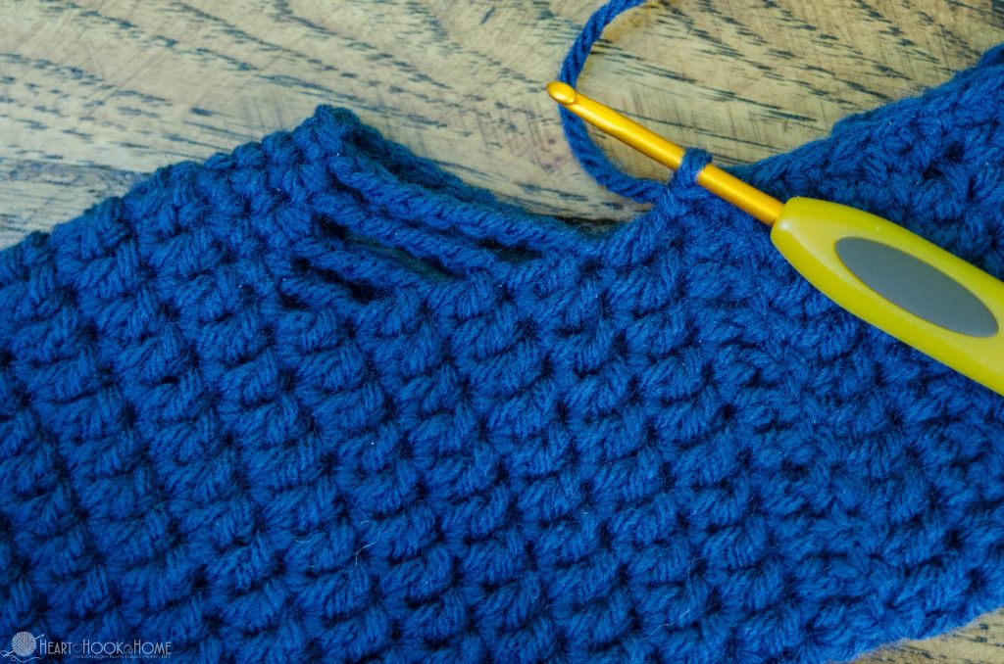
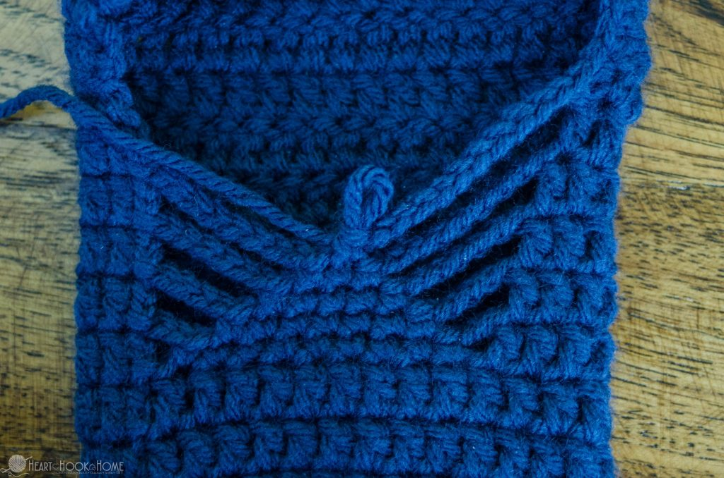
Ch-10, sc in center st. Ch-10, sc in top of other side of row 14, sc in each row end to heel.
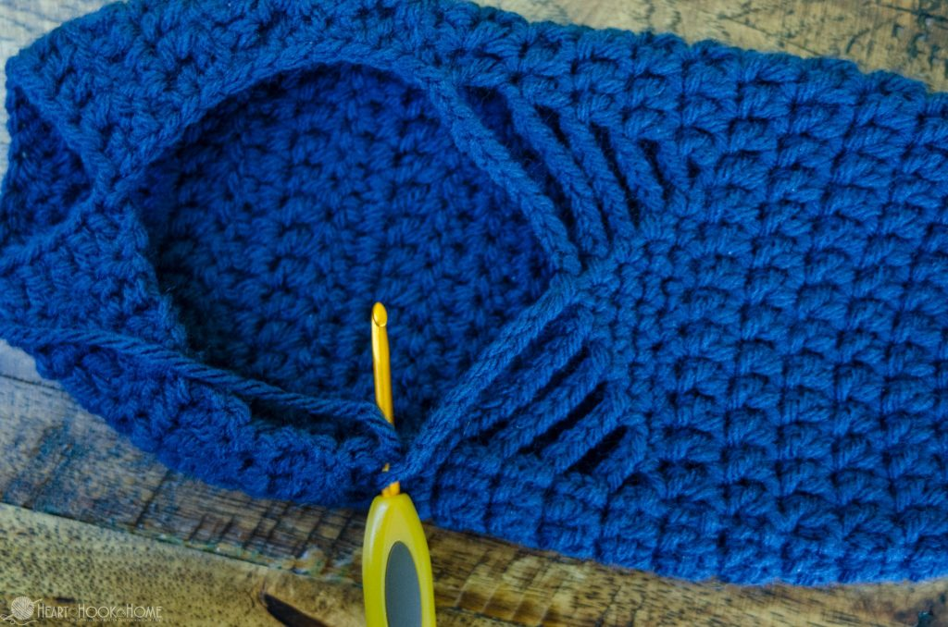
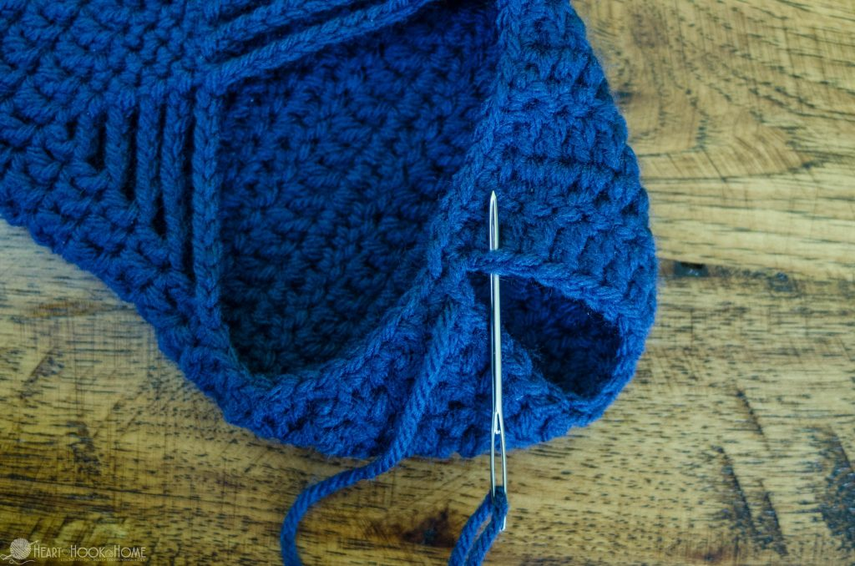
Fasten off and sew down heel using the Mattress Stitch, weave in ends.

